IN THIS ISSUE

FEATURE ARTICLE:

Why Saying “Good Job!” Is Not “Good Practice” page 1

CLASSROOM HINTS:

Learning to Encourage
page 9

TRAINER-TO-TRAINER:

Using Encouragement
page 12

SPECIAL EDUCATION: What It Means to Encourage Children
page 14

NEWS BRIEFS:
page 16
VOLUME 28, NO. 3

Why Saying “Good Job!” Is
Not “Good Practice”

BY SUZANNE GAINSLEY, HIGHSCOPE EARLY CHILDHOOD SPECIALIST AND DEMONSTRATION PRESCHOOL DIRECTOR

One often hears statements like the following from adults, particularly those who work with disadvantaged children: “Our kids are different. They don’t hear positive comments at home. We need to build them up.” “If I don’t praise them, nobody will.” Sometimes it sounds as if children are being lauded for everything they do. “Good job! You threw away the paper towel!” “High five, you found your shoe!” “Thumbs up — you drank all your milk!” With good intentions, parents, teachers, and caregivers have hopped on the praise wagon, hoping to increase children’s feelings of competence and
motivation, and to promote healthy self-esteem. In actuality, researchers are cautioning that praising children is counterproductive to building children’s self-esteem. But
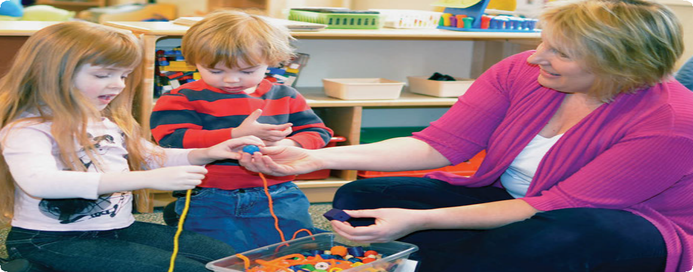before adults jump off the praise wagon, they need to understand how their current practice of praising or rewarding children negatively influences children’s self-esteem.

Encouraging children by commenting on what they are doing allows them to discover their abilities and decide for themselves what they value.

“Children should decide for themselves whether they are satisfied with an action or outcome and learn through their own observations whether they have fulfilled their intentions. This is not
to say that adults have no role in this process.”

PUBLISHER CREDITS

HighScope Extensions is a practical resource for early childhood teachers, trainers, administrators, and child care providers. It contains useful information on the HighScope Curriculum and on HighScope’s training network.
Jennifer Burd Adam Robson Editors

Nancy Goings
Publications Assistant

Nancy Brickman
Director of Publications

Sherry Barker
Membership Manager

Carrie Hernandez
Director of Marketing and Communication

Katie Bruckner
Assistant Marketing Manager

Produced by HighScope Press, a division of HighScope
Educational Research Foundation

ISSN 2155-3548

©2014 HighScope Foundation
The HighScope Foundation is an independent, nonproﬁt organization founded by David Weikart in Ypsilanti, MI in 1970.
And they need an alternative that will better accomplish the laudable goal of helping young children feel confident about themselves and their capabilities. This article will define praise, describe healthy self-esteem, and then explore the negative effects of praise on self-esteem. See this issue’s Classroom Hints article for more effective ways to help children develop a positive yet realistic self-image.

Defining Terms

Before we go further into the benefits of offering children encouragement rather than praise, let’s look at the definitions of praise and self-esteem.

What is praise?

An online search brings up several definitions of praise. What the definitions have in common is the idea that praise involves judgment and approval of someone or something. For our purposes, we can use the definition of praise found in the American Heritage Dictionary: an expression of approval and commendation. Beyond this
simple definition, however, there is confusion about whether there are different types of praise, and how and when to use praise. For example, there are many articles in parenting magazines and journals that discuss how to use praise to motivate children and that make a distinction between “good” praise that compliments children for their efforts (whether or not they tried hard) versus “bad” praise that focuses only on their accomplishments (whether or not they succeeded). It’s no wonder parents and teachers may still be confused about whether they should or should not praise children.
The opposite of praise is criticism. Most adults would never say to a child, “Bad job!” If we did hear someone criticize a child in that way, we might say to that child, “You
don’t need to rely on someone else’s opinion. Decide for yourself. What do you think?” We might even comment that there’s no such thing as a bad job; that when things do not turn out as we planned, the next step is to solve the problem or learn how to do
something better. However, when we say “Good job!” we are also giving a judgment or an opinion. Our response to judgmental words — whether of praise or of criticism — should be the same. That is, children should decide for themselves whether they are satisfied
with an action or outcome and learn through their own observations whether they have fulfilled their intentions. This is not to say that adults have no role in this process. Rather, as discussed below, adults can help children become more adept at self-evaluation.

What is self-esteem?

Self-esteem is a person’s overall opinion of his or her abilities and limitations. People with low self-esteem put little value on their own ideas and opinions and

“Certainly adults want to help children develop positive feelings about themselves,
but they must be careful about the messages they convey to children
through well-intentioned praise. To truly build healthy self-esteem,
may constantly worry that they are “not good enough.” People with high self-esteem do not
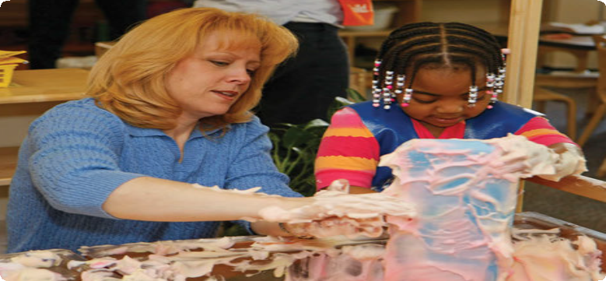question their abilities and opinions. They assume they are correct and,
often, better than others. High self-esteem can be as detrimental as low
self-esteem (Mayo Clinic,
2011). Studies show that children with very high self-esteem may take

Playing as a partner with children lets them know that you value them, their ideas, and their abilities.

children must practice

cultivating their own positive regard from within.”

dangerous risks, or not be open to learning from their mistakes (Baumeister, Campbell, Krueger, & Vohs, 2004). Psychologists and educators instead say that children need to develop “healthy” self-esteem (Egerston, 2006). People with healthy self-esteem have a realistic view of their abilities and limitations and do not let their performance or other people define who they are. Instead, they believe in their capacity for problem solving, learning from experience, and engaging in continuous self-improvement.
Self-esteem begins to develop in early childhood and is influenced not only by experiences but by messages children receive from others. Certainly adults want to help children develop positive feelings about themselves, but they must be careful about the messages they convey to children through well-intentioned praise. To truly build healthy self-esteem, children must practice cultivating their own positive regard
from within. In his article Five Reasons to Stop Saying “Good Job!” (2001), Alfie Kohn reminds adults that children deserve to take delight in their accomplishments but that every time adults say something like “good job,” they are in essence telling children how to feel and stealing children’s opportunities to identify that pleasurable feeling on their own. Alternatively, when adults help them reflect on their actions, describe their efforts and accomplishments, and help them realistically evaluate whether they’ve achieved their own objectives, children learn to decide for themselves how they feel about their outcomes.
Thus, although it may seem counterintuitive, praise can actually harm children (Brummelman, de Castro, Overbeek, & Bushman, 2014). Praising children may lead to one or more of these unintended results:

“When they regularly receive praise from adults, children can lose the process of
self-evaluation.”
1. Children become addicted to praise.

2. Children learn that adult praise is insincere and is used to manipulate them.

3. Children learn to fear failure and avoid challenges.

These outcomes have been shown to negatively affect children’s

• Overall view of themselves as worthy and worthwhile people

• Openness or resistance to constructive guidance

• Ability to self-evaluate

• Motivation to pursue more difficult or challenging tasks

Showing interest in what children are trying to do, rather than praising their achievements, supports children while allowing them to develop their own sense of accomplishment.

Addicted to Praise

When children regularly receive praise from adults, children can lose the process of self-evaluation (i.e., the ability to reflect on the process and outcome of their efforts).
In his article “Rewards and Praise: The Poisoned Carrot,” Robin Grille (2014) says that children may even learn to “fish for flattery” (Grille, 2014, para. 11). That is, they may seek out adult praise by saying things like “My picture is terrible” or “I’m not good at painting,” looking for their praise fix (i.e., so that an adult will say something like “Oh no, it’s beautiful” or “You’re a great painter”). This undermines children’s initiative
and self-motivation. Sometimes children turn into “pleasers,” doing activities or acting

“Another danger for overpraised children is that the absence
of praise can feel like criticism.
If a child counts on hearing ‘Good job,’ then when those words are not forthcoming,
the child may think he or she has failed, or that the adult is displeased with him or her.”
in specific ways to earn praise or rewards at the expense of their own desires. For example, a child’s goal turns from painting a picture in order to experience the pleasure of painting, to painting a picture to receive praise. Surprisingly, evidence suggests that, over time, children who are motivated by praise or rewards actually perform more poorly on tasks, often doing the bare minimum to receive those incentives (Schunk & Pajares, 2005). Further, activities children once enjoyed doing for their own sake tend to lose their appeal when rewards are attached.
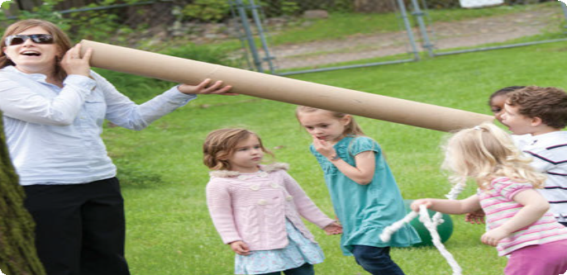Another danger for overpraised children is that the absence of praise can feel like criticism. If a child counts on hearing “Good job,” and those words are not forthcoming,
the child may think he or she has failed, or that the adult is displeased with him or her. While this outcome is not the
adult’s intention — a teacher may

simply be paying attention to another child or taking a positive behavior or outcome for granted
Letting yourself play with children and truly have fun with them lets children know you value them, which helps them build self-esteem.

that day — that is how the “praise-addicted” child sees it.

Manipulated by Praise

“Rewarding children’s compliance is the flip side of punishing their disobedience” (Grille, 2014, para. 13). Teachers may be reluctant to explore alternatives to praise and rewards because praise and rewards seem to work in the short term to get children to comply with adults’ wishes. Praise is manipulative when it draws positive attention to children’s actions so that children will perform that action again. This tactic is often used to get children to participate in classroom activities and routines. For example,
at cleanup time an adult might say to a child, “You’re such a good cleanup helper” or

“I like the way you’re wiping the table” in order to keep the child on task. Praise is also manipulative when it’s used to persuade others to comply with a desired action. For example, an adult might say something like “I see Penny is ready for snack, and look how Charlie is sitting quietly in his seat too,” hoping to motivate other children to follow suit. Though it may sound like positive feedback, in essence, the adult is using

“Praise is also manipulative when it’s used to persuade
others to comply with a desired action.”
praise to control children’s behavior. Grille suggests that praise is the “sweet side” of an authoritarian relationship (Grille, 2014, para. 13).
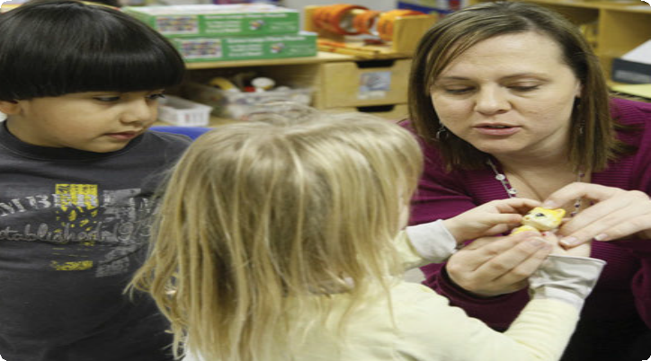The repercussions are that, first, children may catch on to this ploy and manipulate the situation themselves by requiring adults to increase the rewards for desired behavior. For example, they may put away toys to call positive attention to themselves rather than because they are developing a sense of responsibility to take care of their classroom community. A child may even call out to the teacher: “Mrs. Green. See how I’m putting away the blocks?” Secondly, praise may also breed resistance. Children as well as adults tend to resent and resist things that impinge on their sense of control or autonomy. In other words,
using praise can actually backfire, leading to behavior that is the opposite of what adults were looking for. Finally, children may become conditioned to doing things to satisfy adults, at the expense
of their own enthusiasm
for the activity or their own satisfaction. For example, they may look at books, not for the inherent pleasure of reading, but to elicit praise

from the teacher. Or they may use the blue paint because
a teacher has said, “What
Encouraging children to do what they can for themselves
but assisting when needed gives children a sense of self-efficacy.

a pretty picture – blue is my favorite color” rather than exploring other colors and seeing what happens when they are mixed together. Each scenario negatively affects children’s intrinsic motivation and joy of learning, as well as their opportunities for experimentation and discovery.

Frightened of Failure

One of the most compelling arguments against praising children is that the praise can actually inhibit children from challenging themselves with more complex activities for fear of not living up to adults’ high expectations. Children react to the pressure of “Keep up the good work” by thinking “I should quit while I’m ahead.” Researchers have also noticed that children who were generously praised were more tentative in answering

“Life on a pedestal is treacherous, and the wise child may simply climb down”
– Rabbi Neil Kurshan
(as cited in Maynard, 1989)
questions and were more likely to answer in a questioning tone (e.g., “Seven?”). These children were also more likely to abandon their ideas as soon as a teacher disagreed with them and were less likely to persist with challenging tasks (Kohn, 2001).
This phenomenon was also documented in a study by Mueller and Dweck (1998) that examined the effects of different types of praise on children’s achievement. Examiners found that children who were praised for their innate intelligence (“You are so smart. You figured out that problem”) began to attribute their successes to being smart. Unfortunately, when these children experienced failures, they attributed them to a lack of intelligence and appeared helpless to improve the outcomes. They had not learned strategies for dealing with setbacks or failures. When given choices between easy and challenging tasks, these children typically chose tasks that they knew they could succeed at to avoid failure and the risk of losing their “smart” status. On the
other hand, children who were “praised for their effort,” using what HighScope would call encouragement rather than praise (e.g., “You worked hard on that problem”), were more likely to attribute their success to that effort and were more likely to accept
challenges. These types of comments support children without judging them. According to Dweck, “Emphasizing effort gives a child a variable that they can control. They come to see themselves as in control of their success. Emphasizing natural intelligence takes
it out of the child’s control, and it provides no good recipe for responding to a failure”

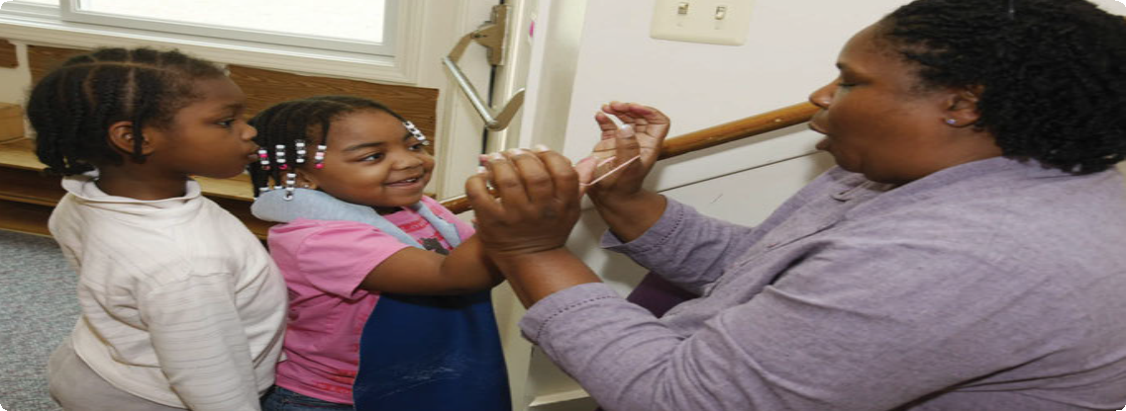(as cited in Bronson, 2007).

Letting children do things for themselves and commenting on what they do respects their growing sense of self.

While praising children may garner results in the short term, in the long run it hinders children’s ability to develop their own evaluative skills and a realistic view of their abilities. Rather than boosting self-esteem, children may actually develop a distorted view of their capabilities. Children also run the risk of turning into “praise
junkies” (i.e., actively seeking praise and validation from others and decreasing their intrinsic motivation) or becoming focused on “image maintenance” (Bronson, 2007). Even after adults understand the repercussions of praising children, breaking those habits takes awareness and practice. The Classroom Hints article in this issue offers
strategies adults can use in place of praise.

Suzanne Gainsley is an early childhood specialist at the HighScope Educational Research Foundation. Also a HighScope certiﬁed trainer and teacher, she ﬁrst began teaching at the HighScope Demonstration Preschool in
1998. She has also worked with infants, toddlers, pre- schoolers, and elementary school children in various settings as a teacher, parent, and volunteer. Gainsley is
the author or co-author of a variety of books published by HighScope Press; includ- ing, most recently, Bringing Active Learning Home: Workshops for Preschool Parents, which is part of the Teachers’ Idea Series.
References

Breube, M.S. [Reference Publisher]. 2010. The American heritage college dictionary. 4th Ed. Boston and
New York: Houghton Mifflin Harcourt.

Baumeister, R. F., Campbell, J. D., Krueger, J. L., & Vohs, K. D. (2004). Exploding the self-esteem myth.
Scientific American, 292(1), 84–91.

Bronson, P. (2007). How not to talk to your kids: The inverse power of praise. New York. Retrieved Septem- ber 7, 2009, from http://nymag.com/news/features/27840/

Brummelman, Thomaes, Orobio de Castro, Overbeek, & Bushman (2014, March). That’s not just beautiful
— That’s incredibly beautiful!: The adverse impact of inflated praise on children with low self-esteem.
Psychological Science, 25, (3): 728–735.

Egerston, H. A. (2006, November). In praise of butterflies: Linking self-esteem and learning. Young Children,
61(6), 58–60.

Grille, R. Rewards and praise: The poisoned carrot. Retrieved May 15, 2014 from http://www.naturalchild.org/robin_grille/rewards_praise.html

Kohn, A. (2001, September). Five reasons to stop saying "good job." Retrieved July 31, 2014, from www. alfiekohn.org/parenting/gj.htm

Maynard, F. (1989, September). Can you praise a child too much? Parents Magazine 64 (9), 94.

Mayo Clinic. (2011, July 23). Self-esteem check: Too low, too high or just right? Retrieved June 6, 2014, from http://www.mayoclinic.org/healthy-living/adult-health/in-depth/self-esteem/art-20047976

Mueller, C. M., and Dweck, C. S. (1998). Praise for intelligence can undermine children’s motivation and performance. Journal for Personality and Social Psychology 75(1): 33–52

Schunk, D. H., & Pajares, F. (2005). Competence perceptions and academic functioning. In A. J. Elliott & C. S. Dweck (Eds.). Handbook of competence and motivation (pp. 85–104). New York: Guilford.

CLASSROOM HINTS

Learning to Encourage

BY SUZANNE GAINSLEY

Why do some adults feel reluctant to give up stickers and continue to praise children? Many adults don’t question the practice of praising and rewarding children because it is familiar. Sometimes we hear
the sentiment “As children, we received gold stars, stickers, and smiley faces on our school work. We turned out okay.” And many teachers are still taught that using praise and rewards is an effective tool for classroom management. Still other teachers have heard that praise may not be good for children, but they do not know what to
do instead. In his article “Rewards and Praise: The Poisoned Carrot,” Robin Grille writes, “Rewards are an easy way out” and “Rewards and praise can be a gimmicky quick fix” (Grille, 2005, para. 22). That’s because they do work in the short term to capture children’s attention or get them to comply with rules and routines. But as early childhood educators, we need to look beyond the short term and remember that so much of what we do with children sets the foundation for future success, whether or not we can see the outcomes right away.
Extrinsic motivators such as praise and rewards may motivate children to participate in activities for a short time. But eventually they reduce children’s enthusiasm for those tasks, and children sim- ply work for the reward, which may lose its value over time and need to be increased to remain attractive. Or children may avoid the activ- ity altogether, whether because adults haven’t made it interesting in its own right, because the reward is disappointing, and/or because children fear failure and the stigma of not being rewarded at all. Ide- ally, we want children to be intrinsically motivated to participate in activities, challenge themselves, and explore new ideas. A positive at- titude toward learning is what will engage children throughout their school years and carry them into adulthood. This article explores
ways to use encouraging statements to acknowledge children’s efforts and accomplishments without the judgmental tones of praise.
There are many ways adults can use encouragement to acknowl- edge children’s initiatives, efforts, and accomplishments, and to help children recognize and evaluate their own actions. Each way involves specific comments directed at what children are doing or have done.

Describe Children’s Actions
One way to encourage children is to simply describe children’s behav- iors and their positive outcomes. The very fact that you are observing and commenting on what the child does sends the message that the

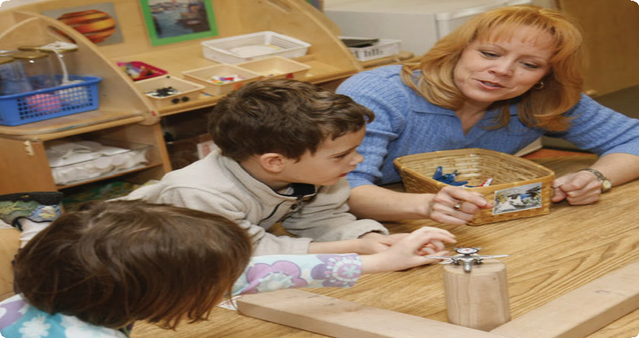activity is worthwhile. For example, an adult might say to a child, “You are climbing up the steps by yourself. You made it all the way to the top.” There might be a tendency to want to add the phrase “good job” to the statement, but why? To help children appreciate their own capabilities, it’s important to point out their accomplish- ments. Yes, climbing the steps is a “big deal” and an adult can be happy for a child. But by omitting the praise words “good job,” the adult allows the child to decide for himself how to feel about his accomplishment. Think how much time children naturally spend practicing a skill until they master it. Would children do that if they didn’t think the accomplishment was its own reward?

Encourage Children to Describe Their Own Work Many young children have already learned to value adult praise by the time they reach preschool. What do adults do when children actively seek out their praise by saying things like “How do you like my picture?” or “Teacher, look what I did!” Often, it is the adult’s attention children want, not the praise, but if praise is the primary type of attention they’ve gotten before, they haven’t learned other ways to capture an adult’s interest. In these situations, encourage children to describe what they did. For example, an adult might simply say something like “I see your painting. Tell me about it” or,

Classroom Hints, continued

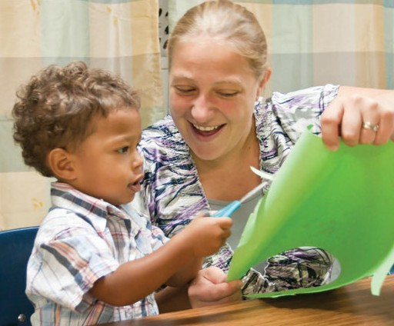

“Tell me how you made that part.” The adult’s goal is to help children discover and appreciate the work that they have done and the process they have gone through. Again, avoiding judging children’s work allows children to reflect on their own ability and find their own plea- sure in the process. It also shows you are paying attention to them
— and at a deeper level of interest than merely offering standard compliments.

Participate in Children’s Play
Another way adults can encourage children to participate in activities and challenge themselves is to be a partner in their play. To partici- pate in children’s play, adults get down on the children’s level, watch

how children use materials, and then use the materials in a similar way. Be sure not to take over the play; let the children retain control, and follow the play themes they introduce. By playing with children and following their lead, adults tell children that what they are doing is interesting and worthwhile.

Encourage Children to Follow One Another’s Ideas and to Help One Another
Just as children feel good about themselves when adults imitate their actions or pick up on their ideas, the same applies to their interac- tions with other children. We’ve all seen how even the quietest children smile with pleasure at large-group time if others imitate a movement they suggest. Teachers can carry this opportunity into
the entire program day. For example, during small-group time, you might comment to the other children at the table, “Tammy is gluing the corners of her paper and Jared is putting a glob of glue in the middle of his.” Children might then imitate the action, describe their own, or make further suggestions to one another. You can also refer children to one another for help. For example, you might say, “Kyle, I see that Carla got hers to stick. Maybe she can show you how she did it.” Helping others solve problems makes children feel competent and encourages them to take on additional challenges. It further decreas- es their dependence on adults for attention and praise.

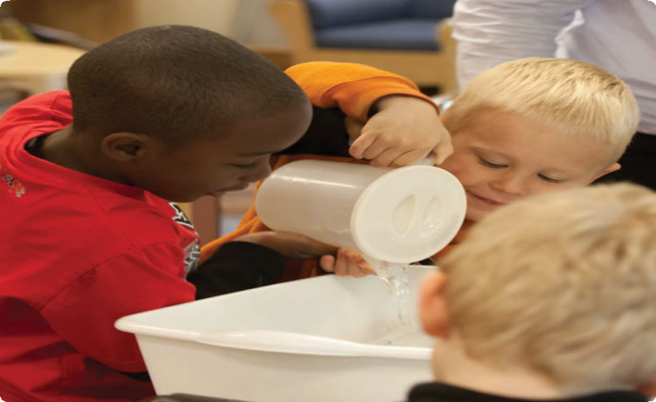• • •
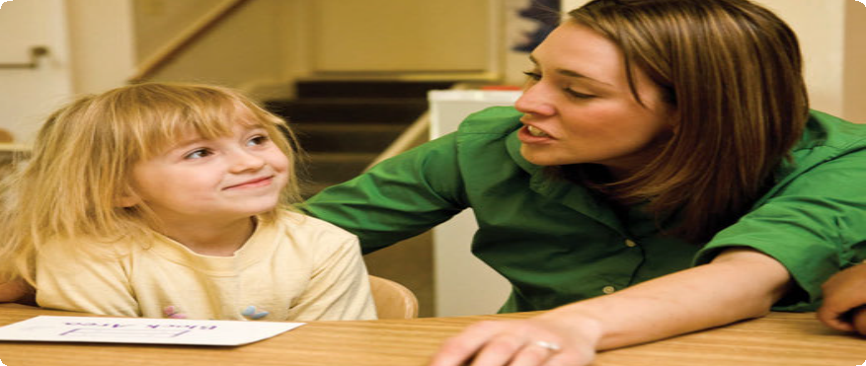In summary, praise focuses on the quality of performance. It can foster fear of failure, dependence on others, and may even create quitters. Encouragement, on the other hand, fosters self-sufficiency, independence, and appreciation for one’s efforts, regardless of the outcome. When adults choose to use encouraging statements, they allow children the opportunity to reflect realistically on their own actions and accomplishments and decide for themselves how these make them feel. The ability to do this is part of healthy self-esteem, a quality that germinates and grows from within.

Focus on Children’s Efforts
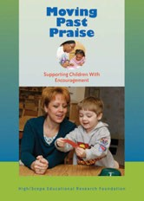As adults participate with children, they can focus encouraging com- ments on children’s efforts (“You are working very hard on that block structure”). Children whose efforts are acknowledged are more likely to challenge themselves than are children who are praised for their innate abilities (e.g., “You’re so good at building”). Effort is something within a person’s control and children learn that extending more ef- fort may make it easier to overcome obstacles. Along with focusing on the effort children put forth, adults can also acknowledge children’s perseverance (e.g., “You kept trying to balance that block and finally
it stayed” or “Even though it is really hard, I see you are still practic- ing”). Acknowledging children’s perseverance and effort, even when children are not successful, helps children feel okay with setbacks and challenges. They learn that an adult’s interest in them is not contingent on stellar performance. Praise on the other hand, focuses on the quality of the outcome. One only earns praise for a “job well done.” From a child’s point of view, effort and perseverance are not
factored in. By focusing on what children are doing, we also avoid the potential mistake of misidentifying their intentions. Think of the em- barrassed teacher who says, “I like the nice doggie you drew,” only to be told by a frustrated child that it’s a picture of her baby brother! If the adult instead says something like, “You spent a long time on your picture. Tell me about it,” the child has an opportunity to describe his or her intentions and the actions that went into achieving them.

Moving Past Praise: Supporting Children With Encouragement

In this DVD, you’ll learn why encouragement is more effective than praise in improving children’s self-worth and self-esteem. You
will discover how to move from praising children to encouraging
them, using three easy-to-implement support strategies. In addition, you’ll observe real classroom examples
of teachers using encouragement to support preschool children and hear tips on how you can incorporate these strategies into your teaching practices.
Available at highscope.org.

DVD: P1361 $29.95 Color, 25 minutes, viewer guide included. 978-1-57379-360-5

TRAINER-TO-TRAINER

Using Encouragement

BY SUZANNE GAINSLEY

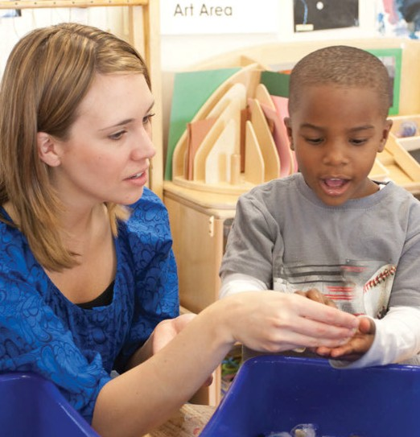

For most adults, switching from using praise to using encourage- ment does not happen overnight. We have been praised ourselves and taught to praise others. It has been ingrained in us and is sometimes automatic. Substituting encouragement for praise takes practice. In this 60-minute workshop, participants will differenti- ate praise from encouragement and use encouragement state- ments that describe children’s actions and accomplishments.

What You Will Need:
For each small group, have a set of each of the following:
• Praise statements written on index cards
• Photos of children engaged in play
• Encouragement statements that are specific to the photos of children engaged in play

Opening Activity (10 minutes)

A Look At Praise Statements

1. Distribute several photos of children engaged in play and participating in other parts of the daily routine to each small

group. Pass out index cards with praise statements written on each. Ask participants to assign an index card with a praise statement to each of the pictures. Bring out these points:
2. As a whole group, compare how the small groups assigned the statements. Discuss how the praise statements can be interchanged among the pictures. Ask participants why they think that is. Bring out these points:
• Praise statements can be interchanged because they are simply generic comments.
• They are statements that, over time, lose their sincerity because children realize they are just empty words.

Central Ideas and Practice (25 minutes)

Negative Implications of Praise

3. In small groups, discuss “Why do adults praise children?” Responses might include the following:
• To help children feel good about themselves
• To show children we care
• To build children’s self-esteem

4. Share the following ideas about the negative effects of praise:
• Children become addicted to praise.
• Children learn that adult praise is insincere and used to manipulate them.
• Children learn to fear failure and avoid challenges.

Encouragement
5. Pass out encouragement cards to each table group. Ask the small groups to discuss the difference between the statements on these cards and those on the praise cards. Talk about how, instead of using praise and rewards, teachers in HighScope settings use statements of encouragement to acknowledge children’s work and effort. Mention that adults use encouragement when they
• Describe children’s work
• Encourage children to describe what they have done
• Focus on children’s efforts and perseverance

Trainer-to-Trainer, continued

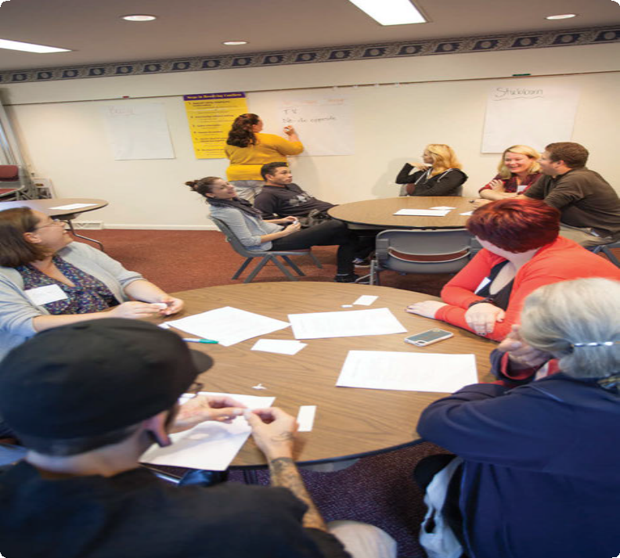6. Have the groups turn back to the photos of children playing and match an encouragement statement to each. Have each group share their matches; with the whole group, compare how the different small groups assigned statements to photos. How was the outcome different from the outcome in the opening activity?
7. Ask groups to discuss how encouragement is beneficial to children. Write ideas on chart paper.
8. Ask each group to select one of the photos and brainstorm on chart paper all of the things they could say to the child in the photo as encouragement.

Application Activity (15 minutes)

9. In small groups, discuss when teachers typically use praise
with children and when they typically use rewards. Brainstorm alternative statements and actions that teachers can say or do to encourage children.

Implementation Plan (10 minutes)

10. Ask participants to select two of the ideas from the Application Activity and write down how they will use them in their own setting.

SPECIAL EDUCATION

What It Means to Encourage Children

BY TERRI MITCHELL, SPECIAL EDUCATION PROGRAMS ADMINISTRATOR, CANYONS SCHOOL DISTRICT, SANDY, UTAH

In the other articles in this issue, we have looked at the potential pitfalls of praise and the benefits of instead offering encourage- ment to all children, and some strategies for doing so. In this ar- ticle, we will consider these things as they pertain to children with disabilities or other special needs. Our discussion will be framed
by the definition of encourage, given in an online dictionary (www. dictionary.com): “to inspire with courage, spirit, or confidence.” Let’s consider what courage, spirit, and confidence mean in our work of supporting young children with disabilities.

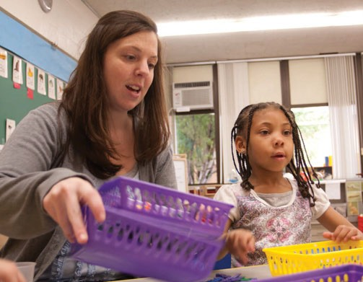

Courage
It takes courage to speak when the words you say are not easily un- derstood. It takes courage to scoot across the floor to get to the area you planned to work in when your legs don’t function properly. It takes courage to learn to regulate your anxiety when you are in a classroom with a lot of movement or noise. These are the experi- ences of many young children with disabilities, and they require courage, often every day. In a classroom where young children with special needs are present, what a marvelous gift it is when adults use supportive interactions to inspire children’s courage, rather than using praise. For example, instead of saying “Good job, you finally said that sound right!” the adult might say, “You are work- ing so hard to say all the sounds…thanks for being patient with
me about understanding what you say.” The latter type of support
inspires the courage to persist and offers a message that what is valued is effort, not just the ability to hit a specific target.

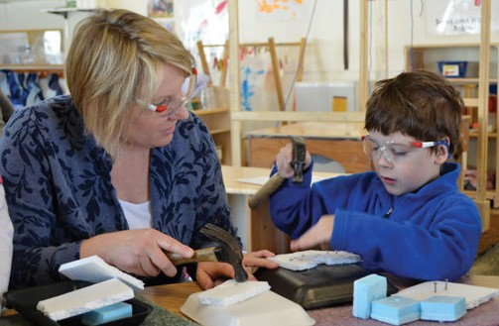

Spirit
As we reflect on the values and characteristics we want our individual programs to support and develop in young children, we will see many of these characteristics in the children we serve. We have all seen young children with “spirit” — for example, the spirit to endure, the spirit to take risks, the spirit to be everyone’s friend no matter what, and the spirit of happiness. Many young
children with special needs come to us with unique characteristics. Some develop much compassion from the life lessons they have already had in their young lives; others may develop patience or a sense of humor. Adults need to support and promote each positive characteristic of “spirit” that they recognize in children, then they can do so through encouragement — encouragement that acknowl- edges the characteristic and makes it clear why it is important. For example, an adult might say, “Alyia, thank you for waiting patiently for James to finish with the large paintbrushes. I am sure he ap- preciates the time to complete his project.” In this example, Alyia has autism and is easily frustrated when trying to communicate
her needs. The adult identifies and encourages patience, perhaps even with a supportive touch on Alyia’s shoulder. Alyia learns that she can be patient in this instance. The adult acknowledged the spirit of patience.

Special Education, continued

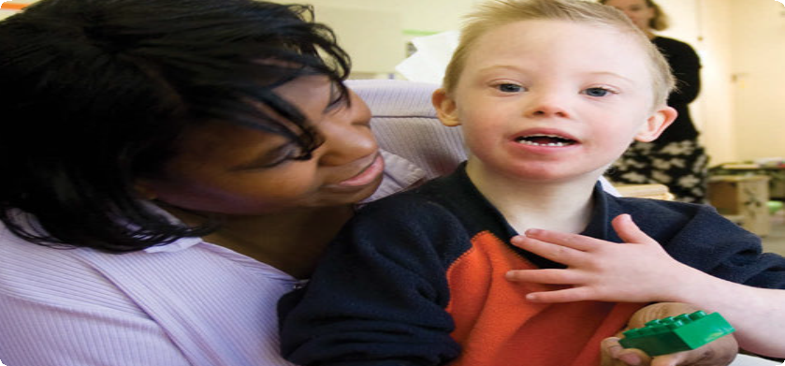Confidence
All of us struggle with confidence at different times in our lives. I have noticed, however, that young children tend to have a lot of natural confidence. This serves them well as they encounter chal- lenging situations with peers and materials. I have noticed that when adults support and inspire confidence in children through encouragement, children exhibit increased engagement, commu- nity involvement, and persistence.
Encouragement teaches children that what they are doing is of value. It gives them the message that it is important and worth ac- knowledging publicly. Imagine Christopher, who uses a wheelchair and has difficulty moving his extremities in a functional manner. During large-group time, an adult inspires confidence through encouragement by stating what Christopher is doing and empha- sizing his effort and improvement: “Did you see how Christopher threw the ball? Christopher, did you notice how the higher you raised your arm the farther the ball went? You must have raised it so high this time! Let’s all see if our ball will go farther if we raise our arms higher like Christopher.” Christopher hears that his
efforts are important and valued. And, though his throw may not look exactly like that of the child next to him, he is learning he can do it!

Inspiration
Considering the struggles — and sometimes battles — young children with special needs experience in their lives, it is crucial to their development that adults acknowledge effort, progress, and the oftentimes small steps of improvement, rather than expressing approval of a “successful” act or behavior. Inspiration has many similarities with “scaffolding” (supporting and gently extending),
a strategy adults use with all children. The idea is that learning never ends. Rather, it is a process of continually moving forward in a series of gradual steps, with adults supporting and “inspiring” children to take that next step on the road to understanding or mastery.
Encouragement comes from a desire to inspire rather than a need to direct or control. Encouragement allows adults to focus on the truly important values rather than always the end goal, and this can inspire children to pursue open-ended possibilities. It also al- lows children to inspire adults. Sometimes, in the realm of special education, we tend to focus more on deficits young children have, and trying to correct these deficits, rather than on acknowledg-
ing the things children can do and accomplish. By using encour- agement, adults can step out of the “fix it” mode to the “watch, listen, and be inspired” mode. Adults can learn from the children themselves the best way to encourage continued participation or persistence in difficult tasks. Encouragement works. Encourage- ment inspires!

Terri Mitchell is a HighScope ﬁeld consultant and currently serves
as the Early Childhood Administrator in Canyons School District in Sandy, Utah. Prior to joining Canyons, Terri was an
educational specialist for the Utah Personnel Development Center, where she directed the training initiatives for early childhood special education classrooms across the state of Utah. Terri is a certiﬁed teacher in special education and early childhood special education. She has contributed her experience with instructional coaching, assessment, and systems change to the development of several high-quality early childhood programs. She co-authored the book
I Belong: Active Learning For Children With
Special Needs (HighScope Press).

NEWS BRIEFS

Weikart Inducted Into the ECMMA Hall of Honor
Phyllis S. Weikart was inducted into the Early Childhood Music
& Movement Association (ECMMA) Hall of Honor on June
23, 2014, during ECMMA's biennial convention in Atlanta. Phyllis served as first the Director, then Senior Advisor, to the Movement and Music Division at HighScope. She developed HighScope's Education Through Movement Program and many HighScope Press books and videos. In 2010 she was presented with a Lifetime Achievement Award for a "lifetime dedicated to teaching children and adults the value of movement and music and its impact on education."
Phyllis is also Associate Professor Emeritus in the School of Kinesiology, University of Michigan, where she served as a faculty member for 25 years. She is the School of Kinesiology's 2004 Life­ time Achievement Award recipient for her service to kinesiology.
Read more about Phyllis and her achievements at the High­ Scope website, highscope.org, and click on News & Info, then Hot Topics.

CEEE Conference
Registration Now Open
Registration is now open for the third Annual "HtGHScOPE. Conference for Early Childhood Research and Evaluation to be held on October 10, 2014, in Ypsilanti, MI. This year's theme is Measur­ ing Program Quality: Translating Research Into Policy and Practice. Kelly Maxwell, Senior Program Area Co-Director of Early Childhood Development of Child Trends will present the opening address.
Panel discussion and poster sessions will follow. For more informa­
tion or to register, visit highscope.org.
Debbie Handler Receives
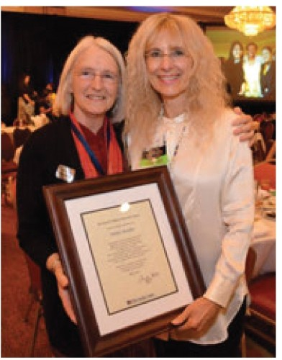Achievement Award
At a luncheon during the 2014 annual HighScope International Conference in May, the HighScope Educational Re­ search Foundation presented the David
P. WeikartAchievementAward to Debbie
Handler (at right of photo).
The award recognizes people outside of the HighScope Ypsilanti staff who the Foundation feels have dem­ onstrated exemplary dedication to HighScope's vision and mission. This dedication may be exhibited through excellence in their training activities, superior implementation of the HighScope curriculum in their setting, or outstanding leadership in their community that has resulted in a high-quality experience for the children they serve.
Debbie Handler has worked in the field of early childhood edu­ cation for more than 40 years. She is a HighScope field consultant and representative for the state of Texas. Debbie has outstanding achievements in teacher training.

New Products From HighScope

Available now at highscope.org

• Bringing Active Learning Home: Workshops for Preschool Parents

• Engaging Young Children WithSpecialNeedsDVD

• Meaningful Math in Preschool

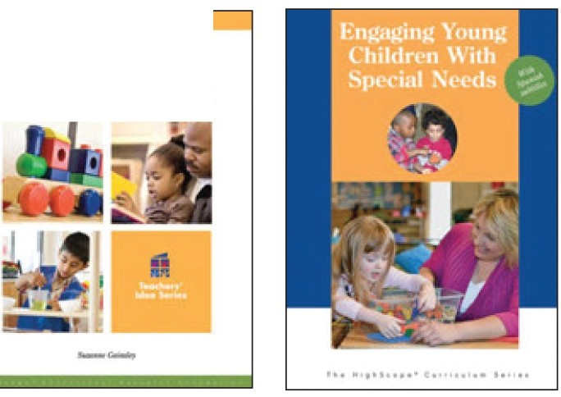COR Advantage 1.5 Print Kit

HighScope Partners With Dexter Early Childhood
Learning Center
The Dexter Early Childhood Learning Center, which is opening in September in Dexter, MI, has entered into an agreement to become a demonstration site for HighScope. The partnership will include HighScope training for Dexter ECLC staff as well as opportunities for educational research funding. Dexter ECLC will implement the HighScope Curriculum in its classrooms, allow HighScope to use classroom observations in their research and educational materials, work with HighScope to develop curriculum for infants and tod­ dlers, and help HighScope conduct research trials.
Bringing Active
....L.....e..a.,rfnt.i..ng Home
w.....tr..,..l.
Meaningful Math
in Preschool
-k u.. ....,

For more information, visit
highscope.org.

