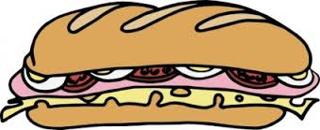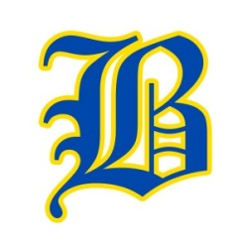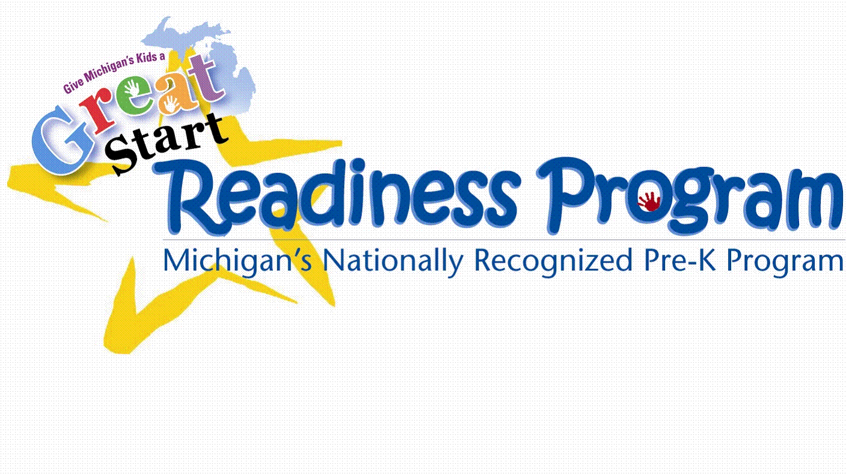

Dear Parents/Caregivers/Family member and friends,
The preschoolers at Buckley Community Schools are trying to raise money for a new playground equipment specifically designed for the younger students of the school. Right now, the preschoolers are unable to play on the current playground equipment at the school because it does not meet licensing requirements for the preschool age students. We have our own playground but would like to make it bigger and add items such as swings.
We will be selling submarine sandwiches for $5.00 each. Customers can choose to order ham, turkey, roast beef or deli chicken breast sandwiches. Each sub will have the customer’s choice of meat and American cheese on a homemade white submarine bun.
Orders will be taken from Monday October 16th until Thursday November 2nd. Payment is to be collected at the time of placing the orders. Checks should be made out to the Buckley GSRP.
ALL ORDERS AND MONEY NEED TO BE TURNED IN TO YOUR CHILD’S TEACHER BY THURSDAY NOVEMBER 2ND
After all of the orders are collected, the sandwiches will be made on Tuesday November 14th. Just in time for Deer camp Parents will then need to pick up the sandwiches that evening in order for the student to deliver the sandwiches.
Thank you for supporting Buckley Community Schools Preschoolers!
Questions? Please call Ms. Jess at 231-409-2414

Submarine sandwich sale facts
¼ lb of meat on each sandwich – choice of Ham, Turkey, Roast Beef, Deli Chicken Breast
3 triangles of American cheese on each sandwich = 1 ½ pieces of cheese
Homemade white sub buns baked day prior to making the subs 7-8”

Subs are sold for $5.00 each. Profit per sandwich for the last 2 times we did this fundraiser:
Buckley Spring 2014 Profit: $3.11 per sub profit 387 subs 387 x 3.11 = $1203.57
Buckley Spring 2016 Profit: $3.03 per sub profit 500 subs 500 x 3.03 = $1515.00

