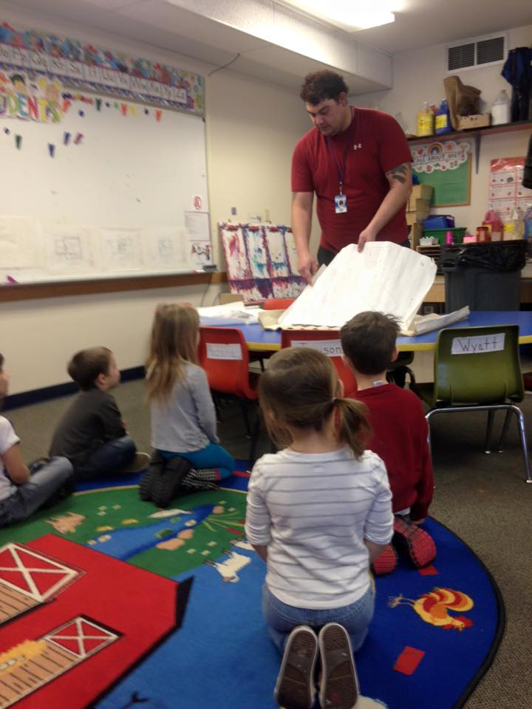 |  | We Love our Dad and want you involved  - Issue Date
Type Tagline Here |  | In This Issue

Getting involved in your child’s education
By Jessica Edinger
Educators would like to help fathers (or any male figure) regain the joys of raising children and being involved in their education. Due to the increased understanding and knowledge of the importance of fathers’ roles in their children’s lives, there is currently more research than ever before to back up what educators have known all along. (Morrison, 390) Over the last decade, the number of dads staying home with the children has doubled. (Morrison, 390) Men are becoming more interested in child rearing and becoming actively involved in their children’s lives and education. Educators should help fathers and other men feel comfortable with their new roles and help teach them as we teach their children. Children who have loving, involved father are more likely to succeed educationally, as well as have healthier self-esteem, can handle the stresses and frustrations of school better than peers with non-involved fathers and have better prosocial behavior. (Morrison, 390)

Ways to be involved
There are several ways Dads can become involved with their kids. Simple everyday things can make a difference in a child’s life.
Page 2
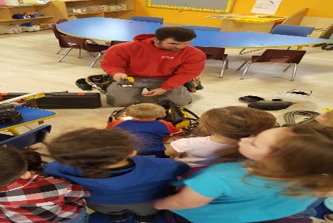
Collaboration between schools and father figures
Schools and teachers should work together with parents to find ways to get dads involved. Most dads would love to be involved if the school asks or host events that interest the father. Page 3
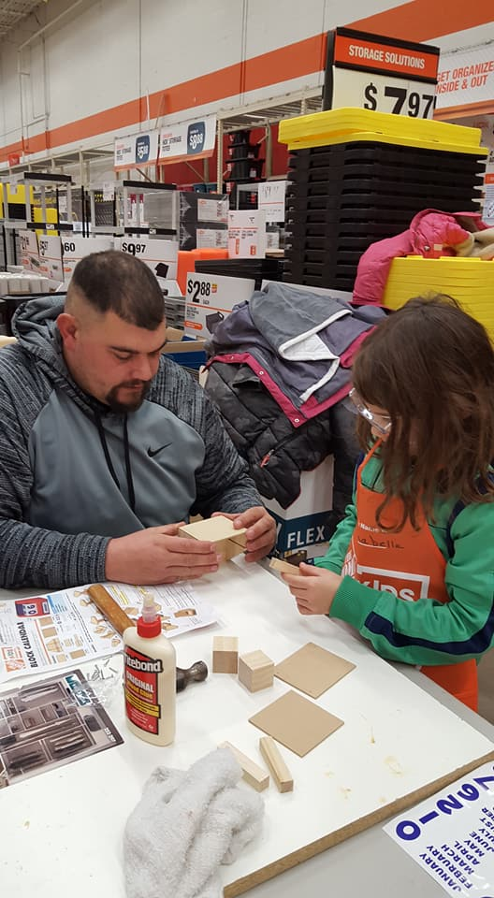

Ways to become involved with your child

Kids LOVE to have dad (or grandpa, uncle or any important male figure in their life) involved in things they do every day! Not everything you do with your kids has to cost money. There are an abundance of free events and activities all over. Being involved can be as simple as reading at night, playing on the floor, or allowing your child help you cook dinner.

IDEAS FOR HOME AND SCHOOL INVOLVEMENT
• Become a mentor at the school (Call school for more information about program)
- Playing outside
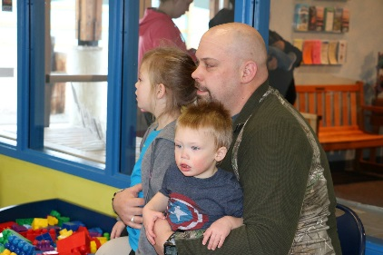
• Come share hobby or occupation in classroom
- Cooking together
• Attend parent/teacher conferences
- Involve your child in your favorite hobby with you
• Read to your child
• Help with homework
• Conversation about daily activities
• Turn off the electronics and have “daddy and Me” time daily
• Volunteer in the classroom
• Go on class field trips
• Participate in PTO, Parent Advisory Committee meetings
• Become volunteer sports coach at school or summer recreation leagues
• Help with program needs
• ASK HOW YOU CAN BE INVOLVED
- Look for free activities to do together – Home depot kids workshops, check Facebook events for things near you
• Attend playgroups

How to get them involved
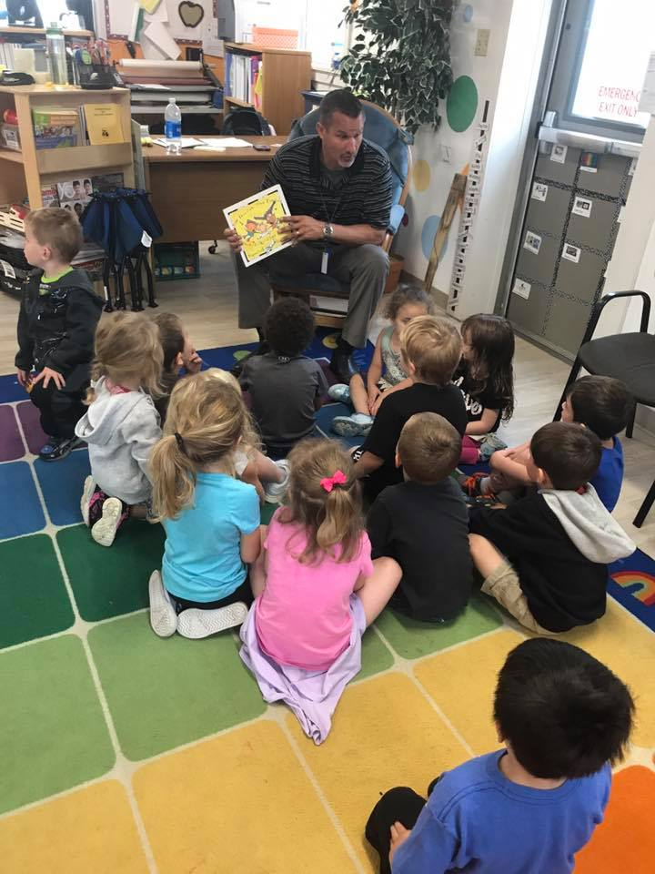

Collaboration between father-figures and schools
- Invite dads into class to share occupation or special hobbies
- Simple surveys just for dads (email or social media might work best)
- Provide special fatherhood or parenting classes/workshops
- Have involved fathers invite other fathers
- Science night
- Sports night
- Specifically invite dads on field trips.
- Make Dads feel welcome
- MOST OF ALL:ASK FATHERS HOW THEY WANT TO BE INVOLVED

Fast Facts

176,000
Stay at home Dads in 2011 in the U.S compared to 86,000 in 2001. (Morrison, 390)
20%
Of single parent males head families. We need to help these dads be involved (Morrison, 391)

For More Information
640,000

gradnparents with gradnchildren under age 18 living with them

There is emerging evidence proving that parental involvement, particularly that of fathers, in early childhood programs have positive influences on their child’s academic success especially when the schools offer training opportunities for parents to learn how to be involved with their students education both at school and at home. (Green, 4) Children, no matter the age, who have involved fathers have healthier self-esteem, show empathy more and have better prosocial behavior compared to the children that do not have involved fathers. (Morrison, 390)
Learning at home is such as, if not more important, than learning at school. By collaborating with parents, children can have the best of both worlds. If schools and parents develop a positive approach to learning together through a partnership, students will have the opportunity to flourish academically and emotionally.
Most classrooms would love to have a Dad come in a read! Do not be afraid to ask.
Involving dads or father figures directly in the schools may take specific planning to start. The best way to do this is to ASK how the dads would like to be involved. Just like in early childhood education, teach and do activities that interest the Dads. If are not able to do things during the week, hold events in the evening or weekends when dads are available.
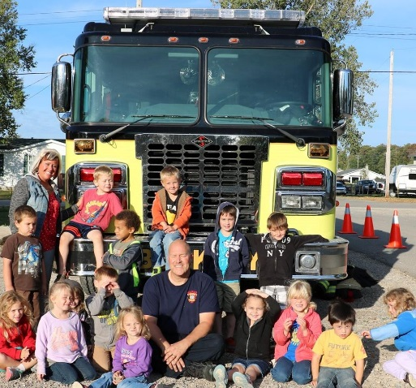
How Teachers can encourage men to be involved

All discussions about father figures becoming involved in early childhood needs to begin with positive ideas and the idea that all fathers want what is best for their children. (Parlakian and Rovaris, 64) Many times fathers want to participate but very often do not know how. Fathers need more encouragement to participate and be involved than mothers do, but this does not mean they care less.

Educators should speak with fathers just as they would mothers; sharing information about the day to day things that happen in the classroom, make them feel important (“your daughter talks about you a lot.”)
In a survey, most fathers shared that they are more apt to participate in events/meetings that are not “men-only” events. (Men support groups, men information nights, etc.) They participate more during completely family functions or where both parents are invited. (Turbiville and Marquis, 229) 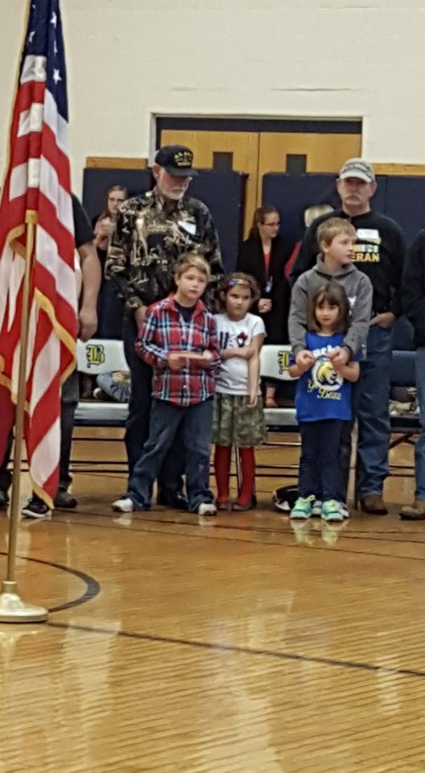
Inviting grandparents to be involved is also a great plan. 640,000 grandparents have their grandchildren living with them, without the parents. (Morrison, 391) These grandparents may need extra help when caring for these kids. Parenting classes or special events for grandparents may make these guardians feel more helpful or welcome.

References
Green, Stephen. (2003). Reaching Out to Fathers: An Examination of Staff Efforts That Lead to Greater Father Involvement in Early Childhood Programs. Early Childhood Research and Practice, Pages 3-13.

Morrison, George. S. (2014). Fundamentals of Early Childhood Education- 7th Edition. New Jersey: Pearson Education, Inc.

Parlakian, Rebecca; Rovaris, J. Michael. (2009). Celebrating Fathers as a Resource in Early Child Care Settings. Young Children, Pages 64-65.

Turbiville, Vicki P; Marquis, Janet G. (2001). Father Participation in Early Childhood Programs. Topics in Early Childhood Special Education, pages 223-231.
Buckley Community Schools

305 S. First Street
Buckley, Michigan 49620

Phone: 231-269-3325
Fax: 231-269-3833
E-mail: jedinger@buckleyschools.com

